Section 1 – General Case Information
Please complete all fields.
Case Number or Citation/Court #
At least one of the two is required for evidence submission.
Email
Please include the email address of the principal investigating officer.

Section 2 – Associated Individuals
Provide the names and requested information about all associated individuals, including but not limited to victim(s), suspects(s), and any individual(s) to be eliminated. Please note, that this field is for named individuals. “Commonwealth of Kentucky” does not need to be entered as a victim.
For each name listed, use the checkboxes to identify whether the individual is a victim, subject, or other (family member, witness, consensual partner, etc.).
Standards/Knowns Submitted
For each name listed, use the checkboxes to indicate which type of standards are being submitted (DNA, Hair, Fingerprints, Not applicable, or None). IMPORTANT: Without relevant standards, comparisons cannot be completed and evidence may be rejected or returned unexamined.
Example:
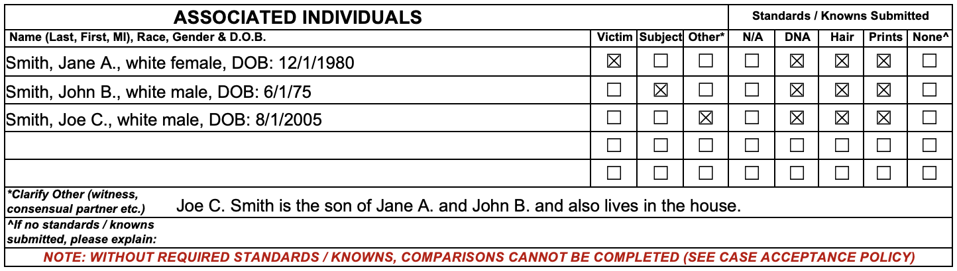

Section 3 – Case History
Provide enough relevant case history for the examiner to determine the most appropriate items and analyses for examination (e.g.- “murder” is not enough information for this field).
Example:
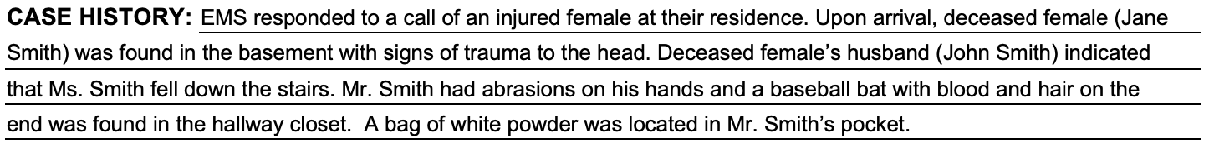

Section 4 – Examinations Requested
Material Submitted
Describe each item submitted for analysis, including the agency item # in the appropriate box.
If items are specifically related to a particular individual, indicate the relevant individual in the description of the item.
For each item, use the checkboxes to indicate which type(s) of analysis is being requested. Items requiring multiple types of analyses (i.e., a gun needing fingerprinting and firearms analysis) should have multiple boxes checked.
Page 2 may be discarded if all submitted evidence will fit on page 1.
Example:
